**Intelligent classification trash projects**

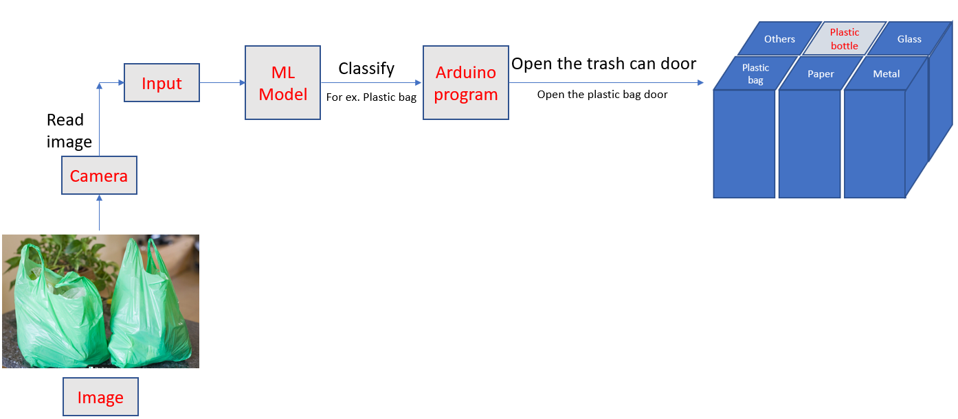Target: To classify the type of trash (metal, paper, plastic, nylon) with real-time processing.